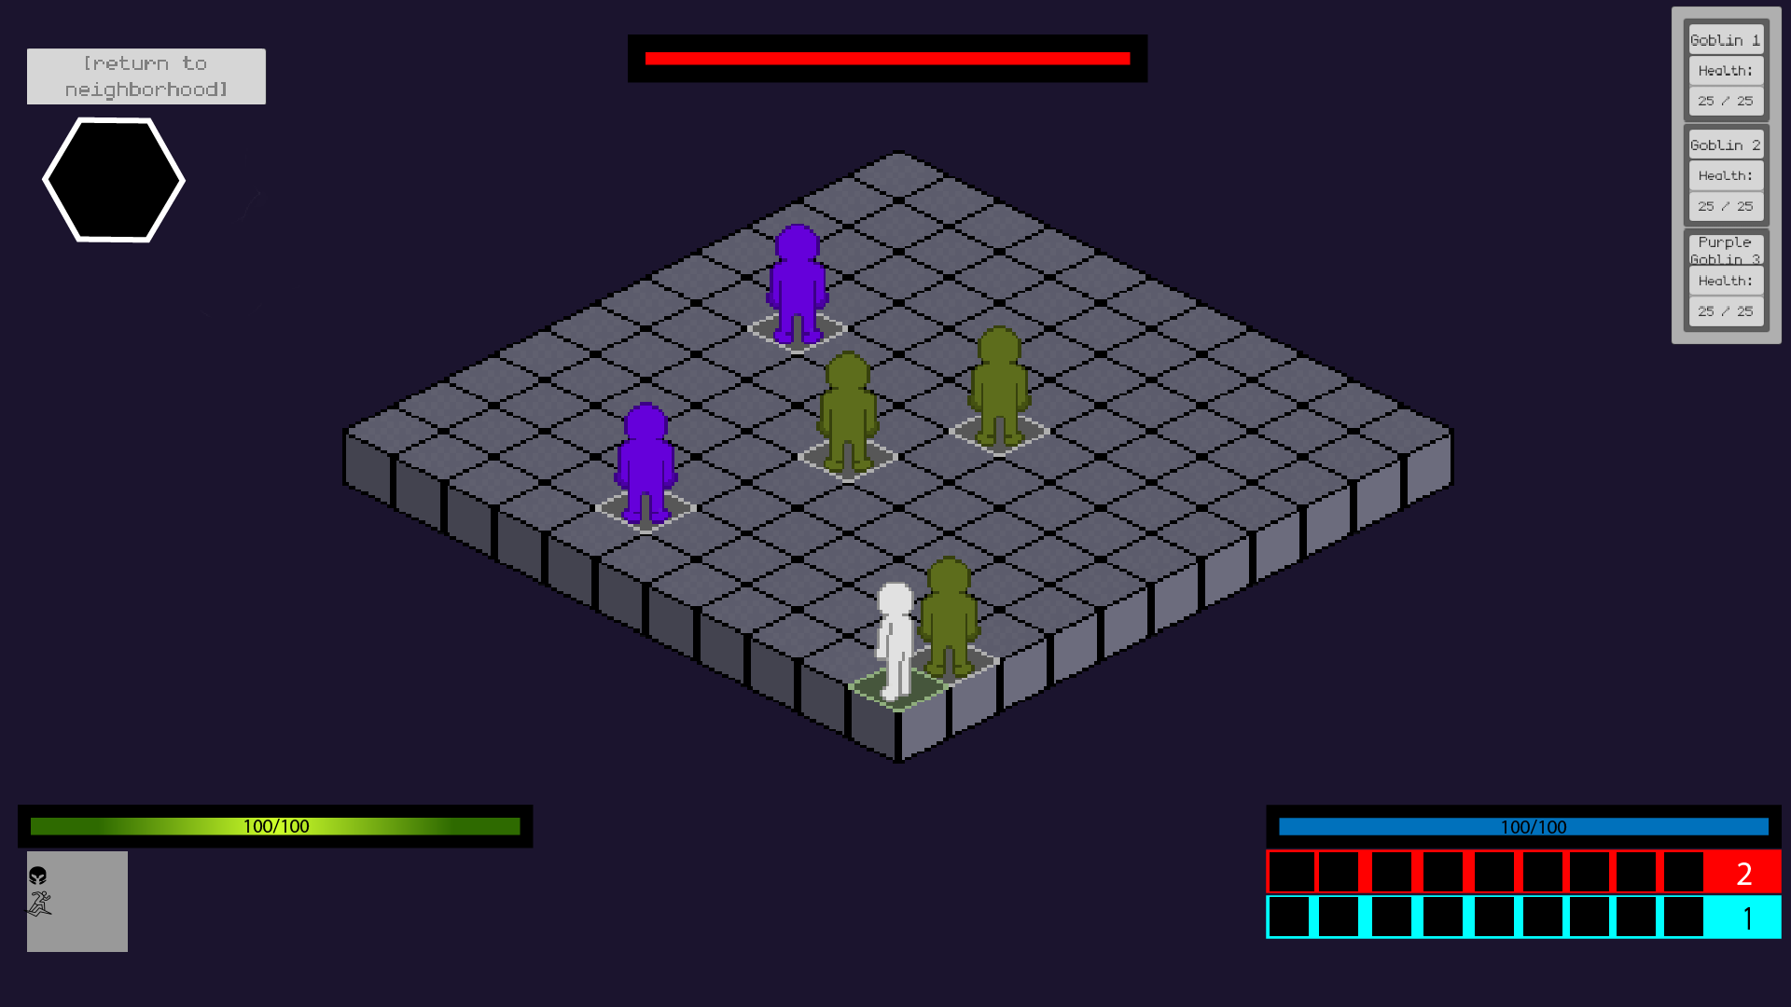

I had an idea to have a little part under the hp bar which can be toggled with a button such as C and this would allow you while in combat to see your miscellaneous stats with their corresponding icon such as stamina, armor, agility. League of legends has something similar to this.

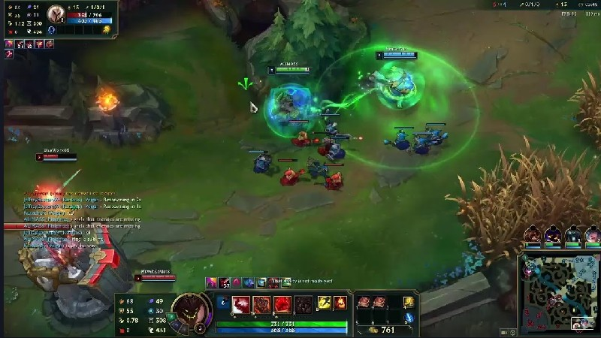

I was also thinking of keeping the small fodder enemies hp displayed like this or not this displayed at all but only keeping the main boss/the strongest enemy of the dungeon hp active.A video game with a pixelated figure

For the abilities I was thinking of inspiration from games like Dead cells, Ffxiv, Risk of Rain 2

and I had an idea of either being able to only use 1 type of attack style at a time for example if I switch to “keyboard 1” I am only allowed to use magic attacks and then “keyboard 2” would be physical attacks or abilites. Or just being able to use both is fine and 1 quickslot inventory would be made with the abilites corresponding to which ever binds are applied to them.

We can also implement instead of having the whole slot for abilities like an icon that display the physical dmg or magic like in league

FFXIV DeadCells

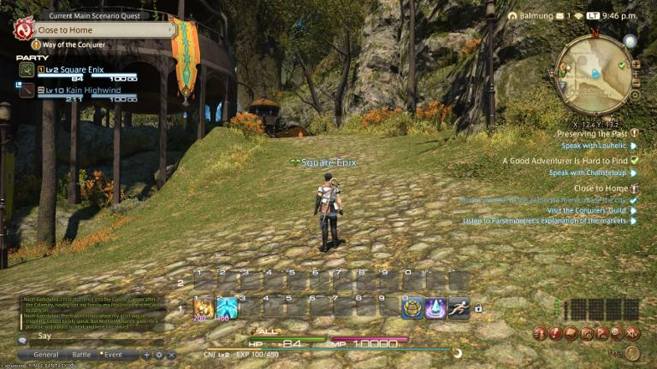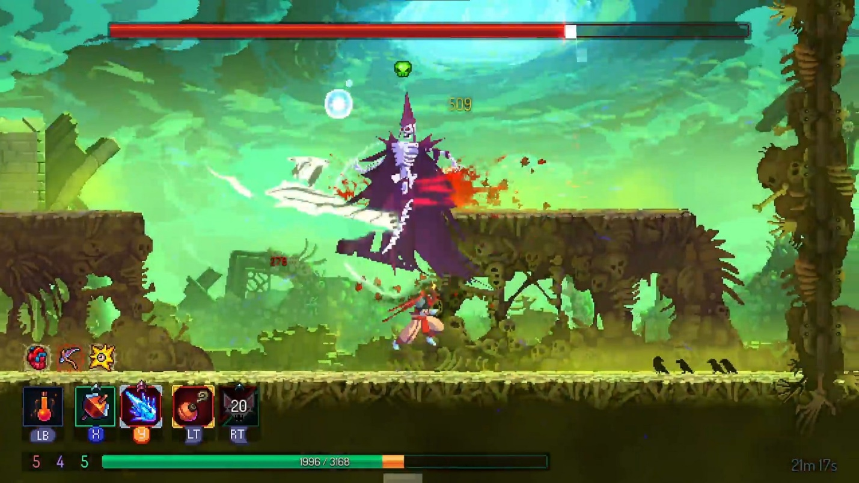

Risk Of Rain

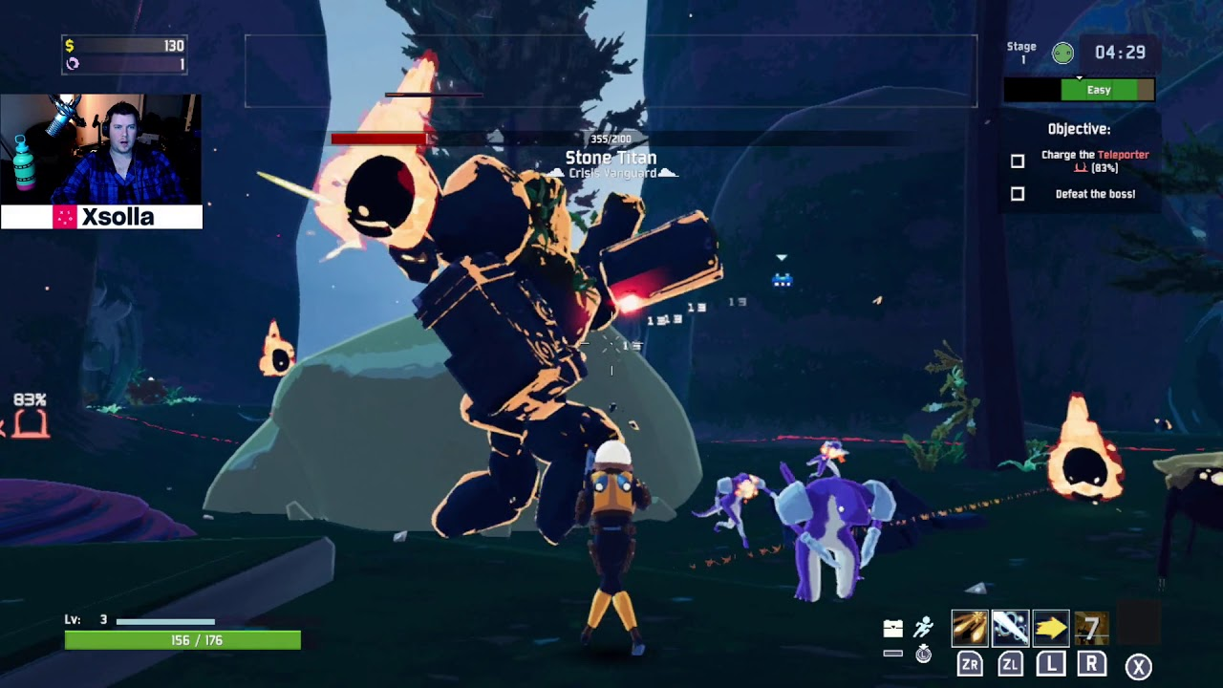

I was also thinking of adding a compass/mini map of the sort along side with the option of bailing on a dungeon.

Elly’s part

Ice Spear:

Healing:

